# First supposition

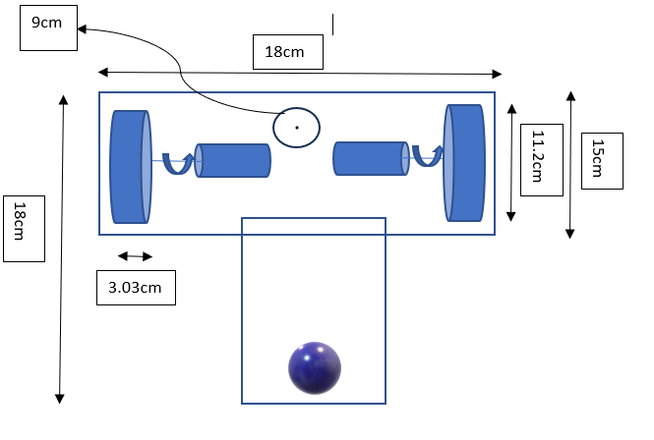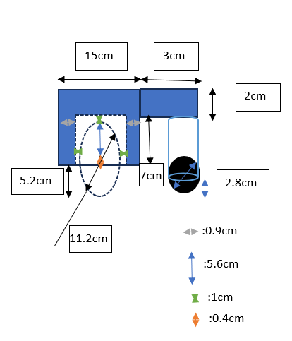spite the consideration that each of those containers will be about 400 cm^3 of volume, we’ll increase this value because of the size of the component (engine) and this increasing might not affected the sizing of the required power. In fact, we firstly suppose that the volume of each part is full, what supposition is not the reality, allowing us to resize the containers without affecting his mass. The real containers will respect the following designs:

